User Guide — TÀI (Super Agent)

TÀI (Super Agent) — User Guide

Overview
TÀI is the unified AI assistant that can invoke all specialist agents from a single chat interface. Instead of switching between agents, you can ask TÀI to translate, summarize, create presentations, brainstorm, query your vault, or analyze images — all in one conversation.
──────────────────────────────────────────────────

How to Access
TÀI is accessed from the TÀI Studio hub via the top navigation. Click the "TÀI" tab in the Dynamic Island navigation bar.

──────────────────────────────────────────────────

Interface Layout
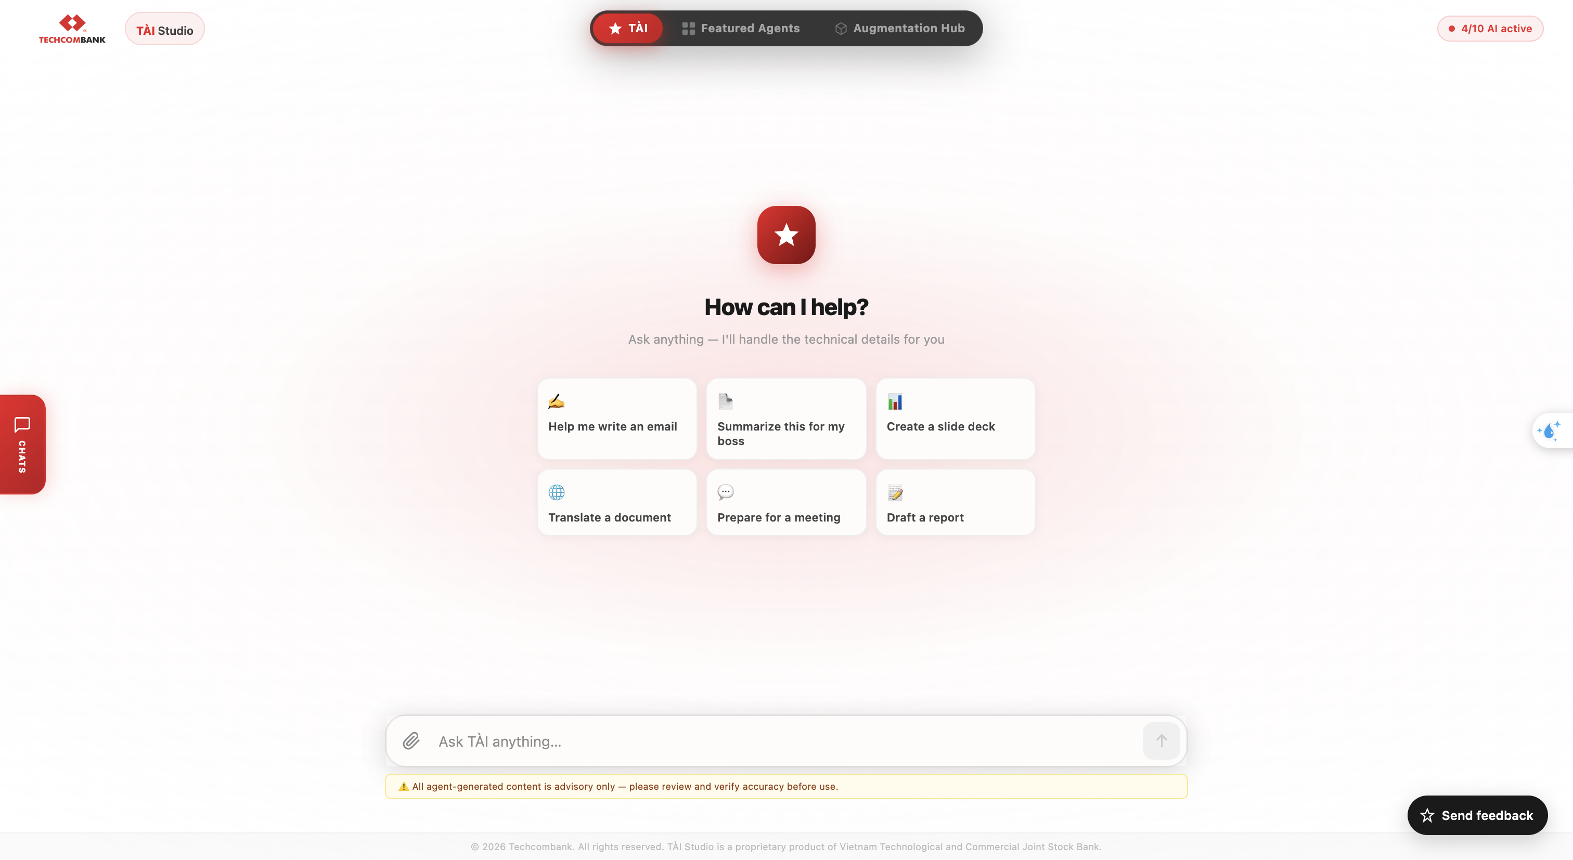
Hint chips (shown on empty chat): Click on the triangle with white star at the middle of screen to show full capabilities of TÀI chat
- 🌐 Translate a document
- 📄 Summarize a report
- 💡 Brainstorm strategies
- 📊 Create a presentation
- ✍️ Help me draft an email
- 🔍 Ask about AI vision
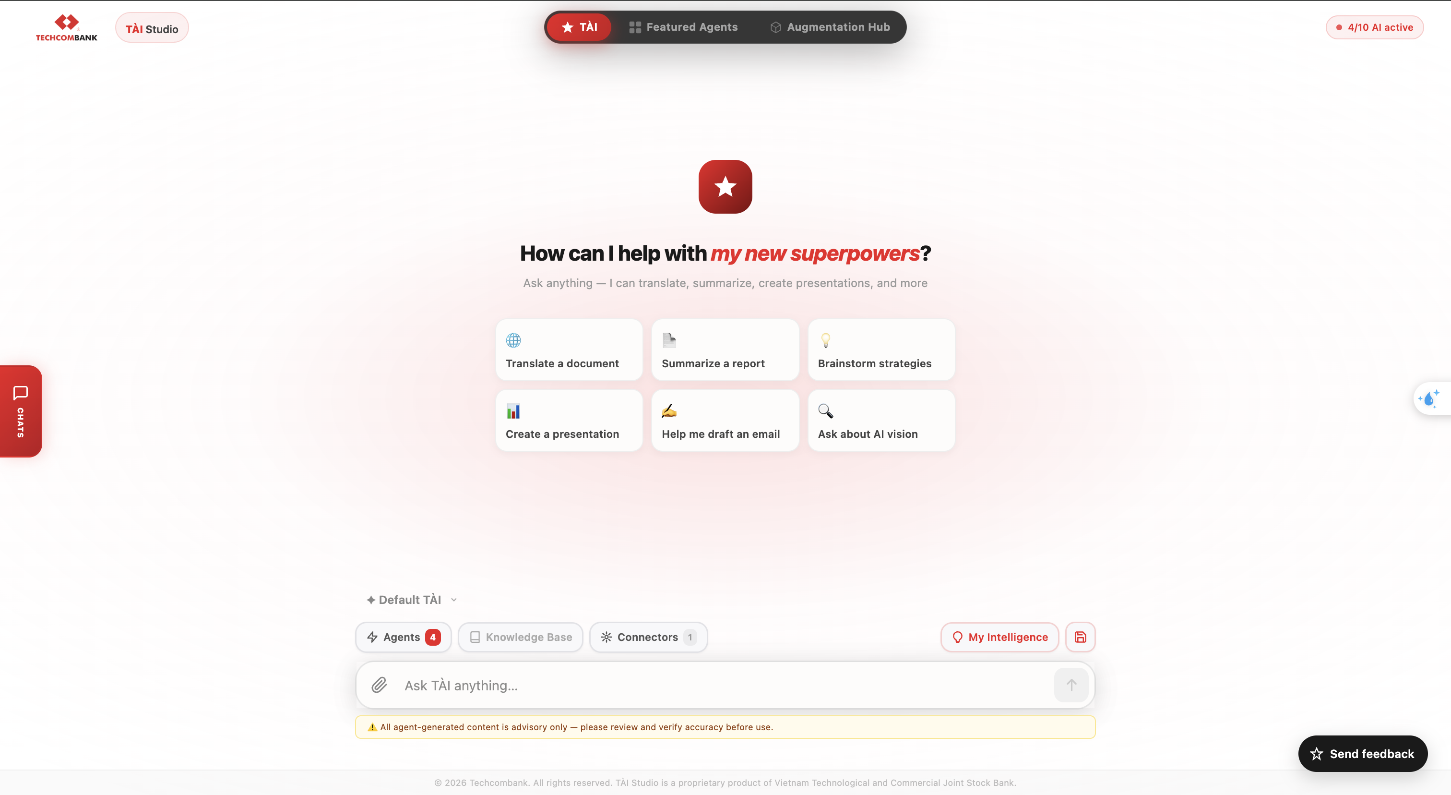
Area | Purpose
Left sidebar | Conversation history (previous sessions)
Center | Chat interface with hint chips
Right sidebar | BYOD (Bring Your Own Data) — manage document indexes
Top bar | Tool selector — enable/disable agent tools
──────────────────────────────────────────────────

How to Use

Basic Chat
Type any message and press Enter. TÀI responds with text, and can also trigger actions like file downloads, presentations, or brainstorm canvases.
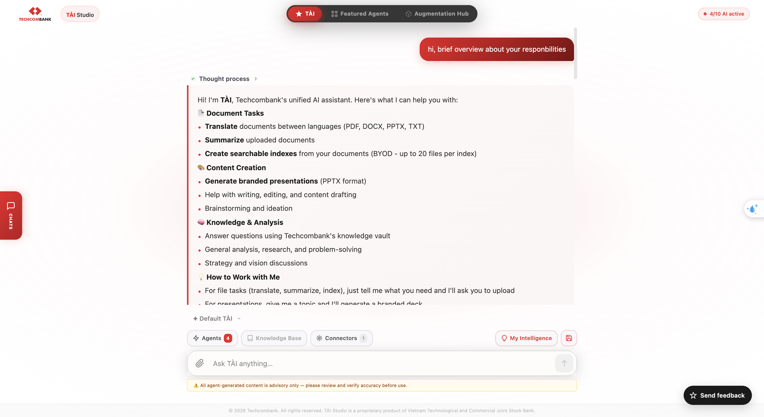

File Upload (Human-in-the-Loop)
When TÀI needs a file (e.g., to translate or summarize), it will:
- Display a file upload card in the chat
- You drag and drop or browse for the file
- TÀI automatically resumes processing once the file is uploaded
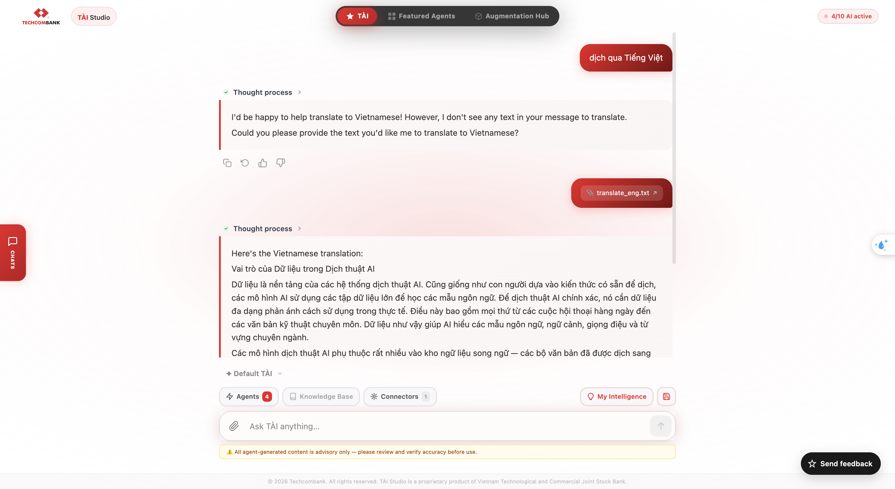
This is the "interrupt → upload → resume" pattern.

Multi-Agent Workflows
TÀI can chain multiple agents in a single conversation:
Example: "Translate this file to English then create a summary slide deck" 1. TÀI asks you to upload the file 2. Calls The Translator to translate 3. Calls The Powerpoint-er to create slides from the translation 4. Returns the downloadable PPTX
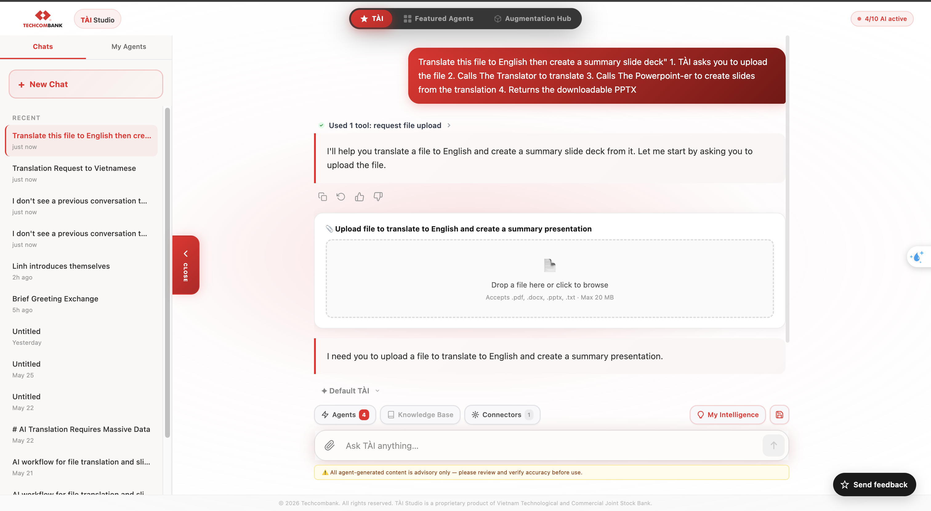

Tool Selector
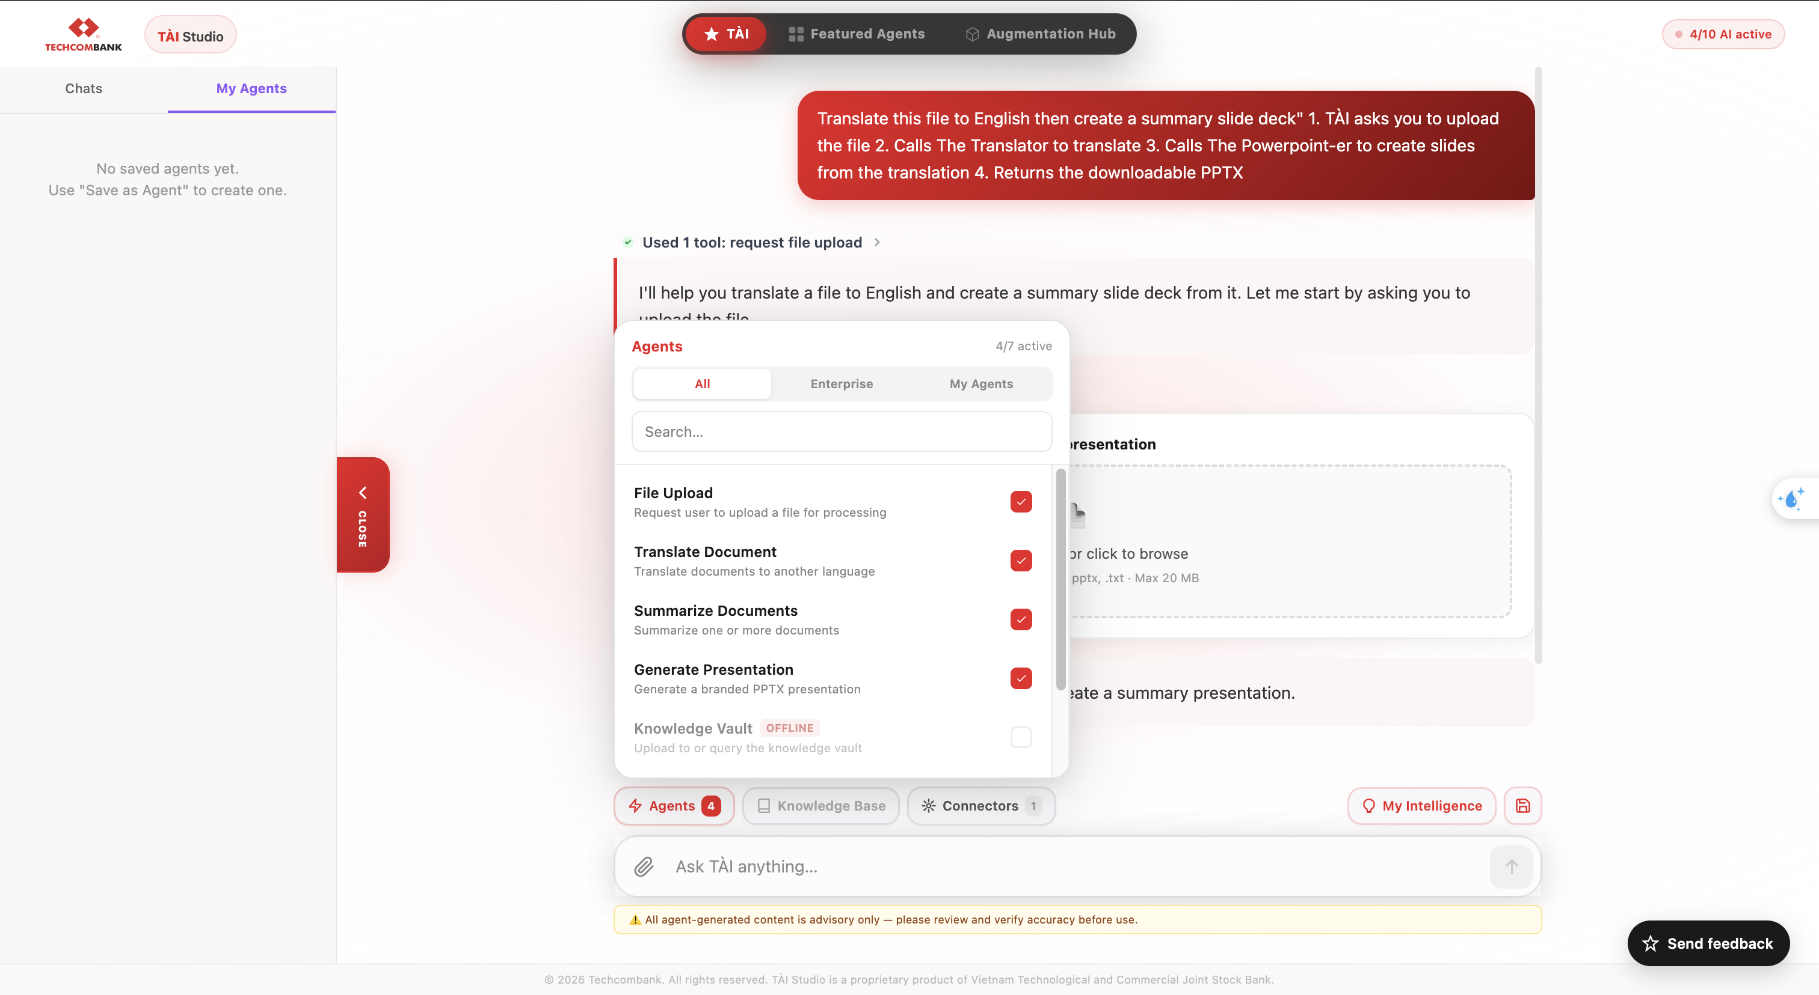
The tools include:
- “Agent” button shows available agent tools (e.g., Translator, Summarizer, PPTX-er) and their current status (active/offline)
- “Knowledge Base” (also check on BYOD Indexes) represents connected data sources used for knowledge retrieval
- “Connector” includes MCP, enabling access to integrated resources
=> Each tool includes a checkbox. Selecting or unselecting this option will enable or disable the tool for use by TÀI.

BYOD (Bring Your Own Data)
The right sidebar lets you manage personal document indexes:
- Create index — Upload documents to create a searchable knowledge base
- List indexes — See your existing document indexes
- Delete index — Remove an index you no longer need
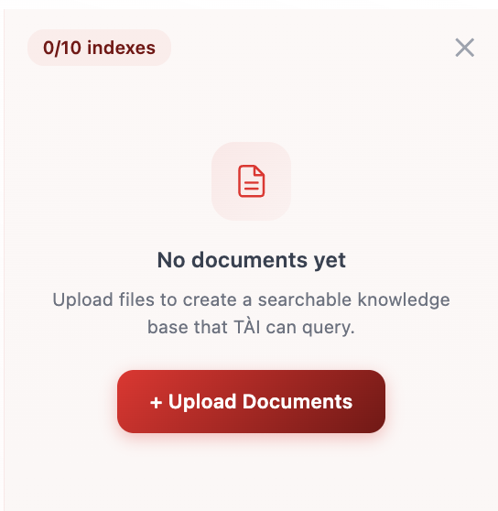
When a BYOD index is active, TÀI can search it to answer your questions with your own documents as context.

Conversation History
The left sidebar shows previous sessions:
- Click any session to reload it
- Start a "New chat" to begin fresh
- Sessions are persisted across browser sessions
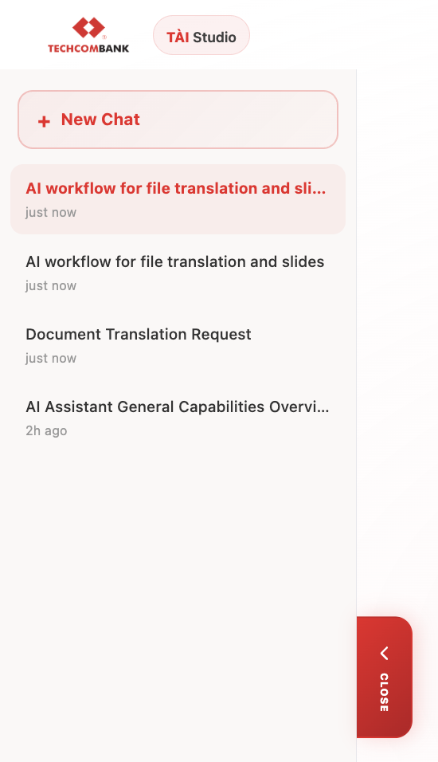

Create Agent
Click the Save icon located to the right of the “My Intelligent” button to open the interface for creating a new agent.
Enter the following details:
- Agent Name
- Description
- Custom Instructions
Click “Save” to create and register the new agent.
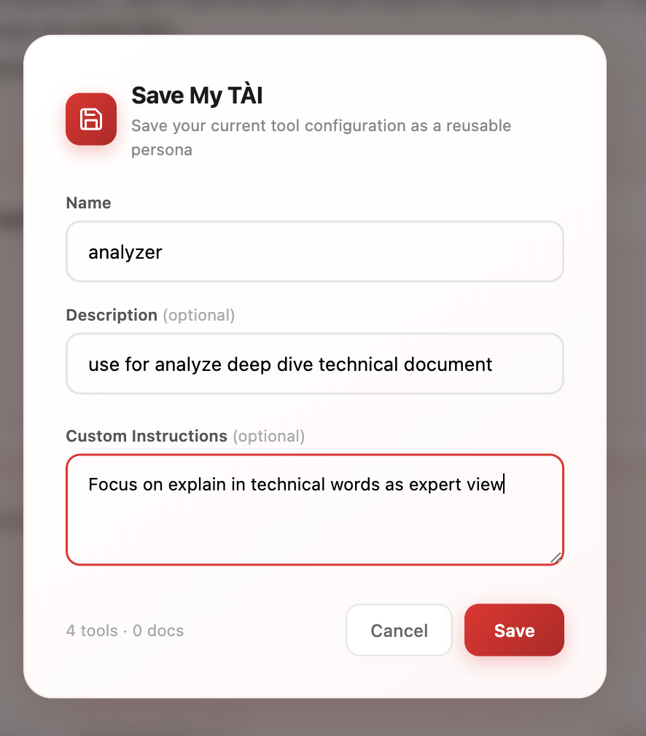
Created agents are displayed in the left panel, alongside the chat history for easy access.
Available actions for each agent:
- Rename
- Update instructions
- Delete
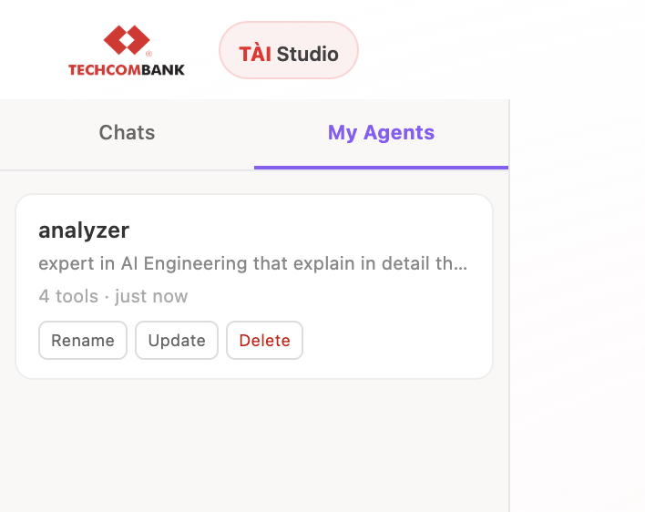
A dropdown list above the chat field contains all available agents, with TÀI selected by default.
Selecting a different agent from this list switches the active agent for the current conversation.
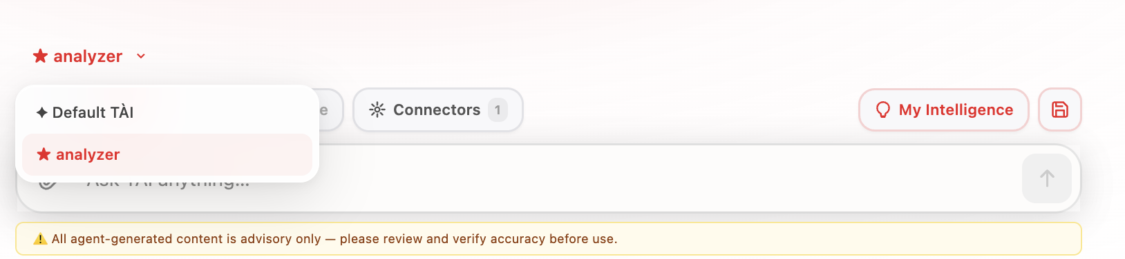

User feedback
If the experience does not meet expectations, feedback can be submitted to the development team by clicking the “Send Feedback” button located at the bottom-right corner. This enables sharing ideas or reporting issues to support system improvement and bug fixes.

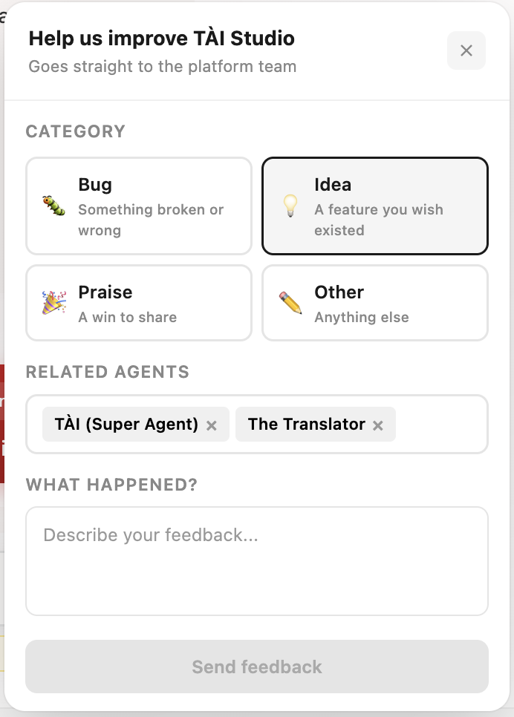
Within the form, a relevant agent can be selected for the feedback. Clicking “Related Agents” will display a dropdown list, allowing selection of one or more agents.
After completing the form, click “Send Feedback” to submit the input to the development team for further enhancement.
Feedback can also be provided directly within TÀI chat responses:
- 👍 Thumbs Up – indicates satisfaction or positive feedback
- 👎 Thumbs Down – indicates dissatisfaction or unmet expectations
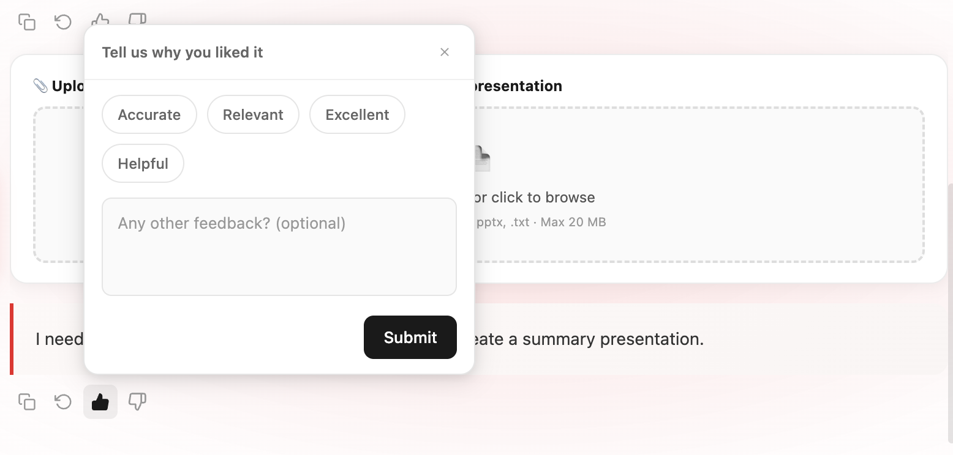
──────────────────────────────────────────────────

Available Tools
TÀI has access to these tools (shown in the Tool Selector):
Tool | What It Does
Translate Document | Translates uploaded files via The Translator
Summarize Documents | Summarizes uploaded files via The Summarizer
Generate Presentation | Creates PPTX via The Powerpoint-er
Create Document Index | Creates a BYOD searchable index
List My Document Indexes | Shows your BYOD indexes
Delete Document Index | Removes a BYOD index
Dynamic MCP tools | Additional tools from Genie spaces and custom integrations
──────────────────────────────────────────────────

UI Actions
TÀI can render special UI components in the chat:
Action | Appearance
File Upload | Upload card with dropzone
File Download | Download button with filename
PPTX Download | Presentation card with slide count and download
Result Card | Formatted result display
Send Feedback | Send user feedback about appication
──────────────────────────────────────────────────

Tips
- Be featured about what you want — "Translate this to English" is better than "Help me with this file"
- TÀI remembers context within a session — you can refer to previous messages
- Use the Tool Selector to focus TÀI on featured capabilities
- BYOD indexes let you ask questions about your own documents without uploading every time
- Multi-step workflows (translate → summarize → present) work in a single conversation
- TÀI adapts to your language preference over time (cross-session memory)
──────────────────────────────────────────────────

Limitations
- Depends on all specialist agents being available (check health status in hub)
- Higher latency for multi-agent workflows due to sequential API calls
- File uploads are limited to 20 MB
- Some complex workflows may require multiple back-and-forth messages
- BYOD indexes take time to build (embedding + indexing)
──────────────────────────────────────────────────
Last updated: 2026-05-28

